Scenario B and C
Vasu Goyal 2023 (N1202625) | Technical Report

Comp 30261: Distributed Database Engineering

Index:
- Scenario B – Telco Log Analytics ........................................ 3-4
2.1 Scenario Understanding ................................................ 3
2.2 Cluster Reflection ...........................................................3
2.3 Database Comparison and Analysis .............................. 4
2.4 Final Recommendation and Reflection ..........................4
- Scenario C – Medical Data Platforms ................................. 5-6
3.1 Scenario Understanding ................................................ 5
3.2 Cluster Reflection .......................................................... 5
3.3 Database Comparison and Analysis .............................. 6
3.4 Final Recommendation and Reflection ......................... 6
- Appendix ................................................................................. 7-9
- References .............................................................................. 10

Scenario B - Understanding:
A telecommunications provider generates extremely large volumes of operational data, including call detail records, network performance metrics, and device activity logs continuously produced across distributed infrastructure. These datasets are typically time-stamped, append-only, and structured or semi-structured, forming high-velocity streams that must be ingested reliably at scale. Because records are generated simultaneously by multiple network components, the system must support sustained high-throughput writes, parallel processing, and fault-tolerant storage to prevent ingestion bottlenecks. In such environments, performance, scalability, and ingestion speed are more critical than strict transactional consistency, as log analytics platforms prioritise rapid data capture for later batch analysis rather than immediate synchronised updates (Stonebraker and Çetintemel, 2005).
At petabyte scale, architectures must rely on distributed storage because single-node systems cannot provide sufficient disk bandwidth, memory capacity, or failure isolation. Distributed file systems such as HDFS are therefore used to support high-bandwidth streaming access and large-scale analytics (Shvachko et al., 2010). Large data platforms also maximise parallelism and data locality so computation occurs where data resides, reducing network overhead and improving processing efficiency (Dean and Ghemawat, 2008). These constraints strongly shape database selection, favouring distributed systems optimised for horizontal scalability and throughput over traditional transactional databases. This requirement reflects CAP-theorem trade-offs prioritising availability and partition tolerance over strict consistency in distributed workloads. Such ingestion-dominated workloads favour log-structured storage engines because sequential disk writes minimise I/O contention under high concurrency.
Scenario B- Cluster Reflection:
Observations from my distributed Hadoop cluster provided practical insight into how large-scale log analytics platforms behave under real operating conditions. The NameNode interface (see Fig. 1) showed that HDFS distributes and replicates blocks across multiple DataNodes, ensuring datasets remain accessible even if individual nodes fail because replicas can be served from alternative machines. Examination of block metadata (see Fig. 2) confirmed that files are physically partitioned across nodes, improving reliability by eliminating single storage failure points while enabling parallel data access for batch processing (Shvachko et al., 2010). This behaviour illustrates practical fault isolation, a defining property of resilient distributed systems.
Monitoring through the YARN scheduler (see Fig. 3) demonstrated that tasks were dynamically assigned according to resource availability, increasing throughput by executing computations concurrently rather than sequentially (Dean and Ghemawat, 2008). Node health monitoring (see Fig. 4) also showed that heartbeat signals allow failures to be detected and workloads redistributed automatically, illustrating partition tolerance in practice. This confirms that real distributed infrastructure must tolerate node failures without interrupting service, a principle that directly informs database architecture selection. These observations indicate that databases for telecom analytics must prioritise parallelism, distributed storage, and fault tolerance over strict transactional guarantees.
Analytical Commentary and Database Comparison Table:
For telecom log analytics platforms, database performance depends on sustained ingestion throughput, distributed reliability, and scalability under continuous data generation.
MySQL ensures transactional correctness through synchronous commits and locking that enforce ACID guarantees, but this coordination overhead limits write throughput and horizontal scaling (Gray and Reuter, 1992). Consequently, relational systems struggle with append-heavy telemetry pipelines where data is written continuously rather than updated. This demonstrates that relational architectures optimised for transactional integrity do not scale efficiently for high-velocity distributed workloads.
MongoDB provides high availability via replica sets that automatically elect a new primary during failure. However, BSON parsing and distributed coordination introduce latency under very high concurrent write loads, meaning that although flexible and resilient, it is not optimised for sustained high-velocity logging ingestion. Although MongoDB improves flexibility, distributed coordination overhead limits efficiency under extreme write concurrency.
Cassandra overcomes these constraints through a decentralised peer-to-peer architecture in which every node accepts writes independently, eliminating single points of failure and enabling linear scalability as nodes are added (Lakshman and Malik, 2010). Its log-structured storage engine is optimised for sequential disk operations, significantly improving write throughput for real-time distributed logging. This architecture shows how decentralised designs remove coordination bottlenecks and enable linear scalability and also minimises coordination latency because request routing does not depend on a centralised metadata authority.
HBase, however, is designed for large-scale analytics and integrates directly with Hadoop storage. While Cassandra excels at real-time ingestion, HBase enables more efficient batch processing across distributed datasets. Its write-ahead logging and region-based storage ensure reliable sequential writes and parallel analysis (George, 2011). Because telecom analytics prioritise scalability, parallel processing, and fault tolerance over strict transactional guarantees, distributed analytical architectures provide the closest alignment. This indicates that systems optimised for analytics may not perform efficiently in ultra-low latency workloads.
Overall, database suitability is determined primarily by architectural compatibility with workload characteristics rather than isolated performance metrics.

Scenario B — Final Recommendation and Reflection
Based on the comparative evaluation, Apache HBase is the most suitable database for telecom log analytics systems. These workloads involve continuous high-velocity ingestion, petabyte-scale storage, and batch analysis, meaning architectures optimised for sequential writes and distributed processing outperform traditional transactional databases (Stonebraker and Çetintemel, 2005). HBase is designed for distributed environments and integrates directly with Hadoop, enabling parallel computation across nodes while maintaining persistence through replication and write-ahead logging (Apache Software Foundation, 2024). This choice reflects architectural alignment with write-optimised distributed storage models rather than general-purpose database performance.
Evidence from my Hadoop cluster supported this choice. The NameNode interface demonstrated that replicated blocks allow data to remain accessible even when nodes fail, while YARN monitoring showed that tasks are redistributed dynamically to maintain throughput. These mechanisms reflect the same principles underlying HBase’s region-server architecture: decentralised storage, workload partitioning, and fault tolerance. Although Cassandra offers very high ingestion performance through its peer-to-peer design, HBase provides stronger compatibility with batch analytics pipelines and structured large-scale processing (Chang et al., 2008). This analysis strengthened my understanding that database selection must align system architecture with workload behaviour rather than relying solely on theoretical performance characteristics. It also showed that practical system behaviour often reveals constraints not immediately visible in theoretical specifications .This decision reflects CAP and PACELC trade-offs between consistency, availability, and latency

Database | Consistency | Availability | Fault Tolerance | Write Performance | Transaction Model | Scenario Suitability
MySQL | Strong ACID via synchronous commits | Moderate failover requires replica promotion | Replica redundancy but master is bottleneck | Limited locking + transaction logging slow ingestion | Full ACID | Unsuitable centralised architecture restricts high-velocity distributed log writes
MongoDB | Tunable via write concern | High replica sets auto-elect new primary | Automatic failover + data replication | High but BSON parsing adds overhead | Multi-document ACID (costly) | Partial flexible storage but not optimised for sustained petabyte log pipelines
Cassandra | Tunable consistency (ONE→ALL) | Very High masterless architecture avoids single failure point | Excellent data replicated across nodes | Extremely High log-structured storage + sequential writes | Lightweight only | Strong ideal for distributed ingestion workloads
HBase | Strong per-row consistency | High region servers failover via HDFS replication | Very strong WAL + distributed storage | Very High append-optimised writes | Row-level atomicity | Best designed for massive distributed analytics + Hadoop integration

Scenario C - Understanding: A digital healthcare organisation that collects data from wearable devices, diagnostic systems, and clinician reports must manage highly heterogeneous datasets generated continuously from multiple sources. Unlike traditional enterprise databases that handle fixed structured records, this environment includes semi-structured and unstructured information such as sensor readings, medical images, text notes, and device telemetry. Because new medical technologies and monitoring formats are frequently introduced, the storage platform must support flexible schema evolution without requiring costly redesign. In addition, rapid retrieval of individual patient records is critical for clinical decision-making, meaning the system must deliver low-latency queries alongside scalable storage capacity. Heterogeneous medical datasets require schema-on-read capabilities rather than schema-on-write enforcement.
From a system design perspective, healthcare data platforms prioritise adaptability, horizontal scalability, and efficient querying of nested data structures rather than rigid transactional guarantees. Hhealthcare systems often prioritise availability of patient data over strict transactional synchronisation during distributed access. Document-oriented and schema-flexible databases are well suited to such workloads because they allow evolving data formats while maintaining performance and accessibility (Banker, 2011). Distributed storage is also essential, as healthcare analytics infrastructures must handle continuously growing datasets reliably across nodes (Armbrust et al., 2010). These requirements strongly influence database selection by favouring systems capable of managing diverse data types and dynamic schemas while preserving fast access to individual records.
Scenario C - Cluster Reflection: Observations from my distributed Hadoop cluster provided practical insight into how systems handle heterogeneous and evolving data at scale. The NameNode monitoring interface (see Fig. 1) showed that HDFS stores data across multiple DataNodes using block distribution and replication, confirming that diverse datasets remain accessible even if individual nodes fail. This demonstrated how distributed storage architectures support fault tolerance and availability when managing large volumes of unstructured or semi-structured information. Examination of block placement metadata (see Fig. 2) further illustrated how files are partitioned across nodes, enabling parallel access and improving retrieval efficiency for large datasets (Shvachko et al., 2010). This demonstrates how distributed scheduling frameworks exploit task parallelism to improve throughput without increasing individual node performance.
Resource scheduling behaviour observed in the YARN interface (see Fig. 3) indicated that tasks were dynamically assigned to nodes depending on workload conditions, highlighting how distributed platforms optimise performance through parallel execution. Node health monitoring (see Fig. 4) also confirmed that heartbeat signals allow systems to detect failures and redistribute processing automatically. These behaviours demonstrate how distributed environments prioritise scalability, availability, and efficient data access—properties essential for healthcare data platforms that must handle diverse data types and rapidly retrieve individual records. This practical experience reinforced the importance of selecting database architectures capable of flexible storage, distributed processing, and resilient data management.
Analytical Commentary and Database Comparison Table: Healthcare data platforms must support heterogeneous and evolving information types, including sensor telemetry, images, and clinician notes. These datasets require storage systems capable of adapting to changing schemas while still enabling efficient retrieval of individual patient records. Traditional relational systems such as MySQL enforce rigid schemas that ensure strong consistency but limit adaptability, making structural modifications costly and disruptive (Stonebraker and Hellerstein, 2005). This rigidity conflicts with healthcare environments where new device formats and data attributes are introduced frequently.
Cassandra provides excellent scalability and fault tolerance through its decentralised architecture and partition-based storage, allowing it to manage large volumes of distributed data efficiently (Lakshman and Malik, 2010). However, its query model is optimised for key-based retrieval rather than complex document-style searches, which reduces flexibility when handling varied patient records. HBase supports large-scale distributed storage and offers strong consistency at the row level, but its schema design still requires predefined column families and is primarily optimised for analytical scanning rather than flexible document retrieval (George, 2011).
MongoDB most closely matches the requirements of this scenario because its document-oriented data model allows hierarchical storage of diverse patient information within single records. This structure improves performance by enabling related data to be retrieved in a single query rather than requiring joins across multiple tables (Banker, 2011). Combined with horizontal scaling and automatic failover mechanisms, these characteristics make MongoDB particularly suited to healthcare platforms that require both flexibility and rapid access to individual records. This analysis shows that schema flexibility and distributed query efficiency are decisive architectural factors for heterogeneous data systems.
Database | Schema Flexibility | Query Performance | Scalability | Fault Tolerance | Transaction Strength | Scenario Suitability
MySQL | Fixed schema; structural changes require costly migration and downtime | Highly efficient for structured relational queries and joins | Primarily vertical scaling; horizontal scaling requires manual sharding | Replica failover supported but primary node remains coordination bottleneck | Full ACID guarantees with strict consistency | Poor , rigid schema unsuitable for evolving medical data formats
MongoDB | Dynamic schema; fields vary per document | Efficient retrieval of nested and hierarchical records in single queries | Horizontal scaling through automatic sharding | Replica sets provide automatic failover and redundancy | Limited multi-document ACID support with performance trade-offs | Best — handles diverse patient data with flexible structure
Cassandra | Semi-flexible column families | Optimised for high-speed key-based reads rather than complex queries | Linear horizontal scalability via distributed partitioning | Masterless replication eliminates single points of failure | Limited transactional guarantees (no full ACID) | Moderate scalable but limited complex querying
HBase | Column families fixed; qualifiers flexible | Optimised for large sequential scans rather than rich queries | Horizontal via region splitting across nodes | HDFS replication + WAL | Row-level atomicity only; lacks multi-row transactions | Scalable distributed storage but architecturally less suited for document-centric query patterns

Scenario C — Final Recommendation and Reflection: Based on the comparative analysis, MongoDB is the most appropriate database for managing heterogeneous healthcare datasets generated by wearable devices, diagnostic systems, and clinical records. Its document-oriented architecture allows flexible schema evolution, enabling new data types to be stored without restructuring existing datasets, which is essential in medical environments where technologies and data formats change frequently (Banker, 2011). Unlike relational systems such as MySQL that require predefined schemas, MongoDB stores hierarchical data within single documents, allowing rapid retrieval of complete patient records while maintaining scalability through horizontal sharding and automatic replication. These characteristics align closely with the scenario requirements of flexibility, low-latency access, and distributed reliability. Practical observations from my Hadoop cluster reinforced this conclusion. Distributed block storage and replication demonstrated how large datasets can remain accessible despite node failures, while parallel task execution highlighted how scalable systems manage complex workloads efficiently. These behaviours mirror MongoDB’s distributed design, which balances availability and performance while tolerating temporary inconsistencies when necessary (Chodorow, 2013). The document model reduces query complexity by co-locating related data, thereby avoiding distributed join operations. Although MongoDB sacrifices strict relational constraints and may require application-level consistency handling, these trade-offs are acceptable in healthcare analytics environments where adaptability and rapid data access are more critical than rigid schema enforcement. This evaluation strengthened my understanding of how real distributed system behaviour directly informs database selection decisions. Effective database selection is fundamentally an architectural decision rather than a feature comparison exercise. Distributed database design is ultimately an exercise in managing trade-offs between coordination cost, consistency guarantees, and system latency.

Appendix-
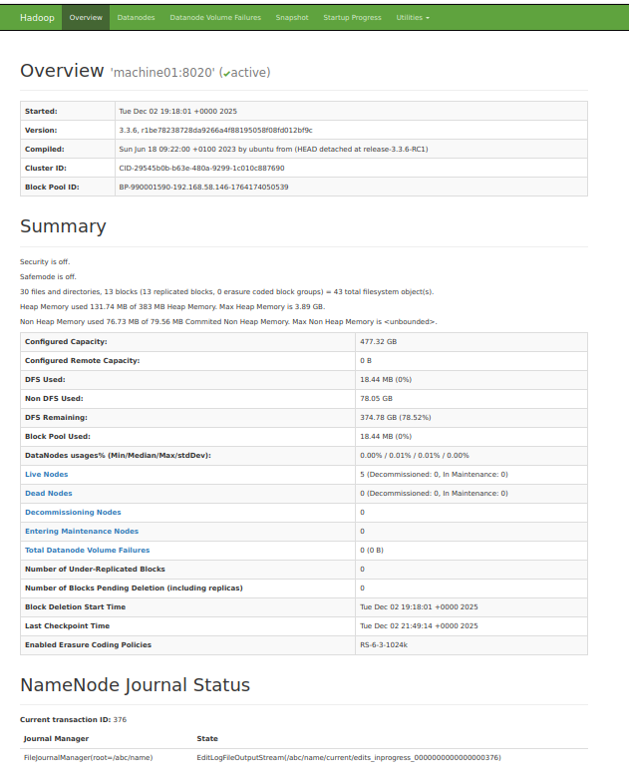
Fig. 1. HDFS NameNode dashboard showing active DataNodes, storage distribution, and cluster status.
This screenshot displays the NameNode monitoring interface showing cluster capacity, active nodes, and distributed storage metrics. It confirms that data blocks are automatically replicated across nodes to ensure fault tolerance and availability.

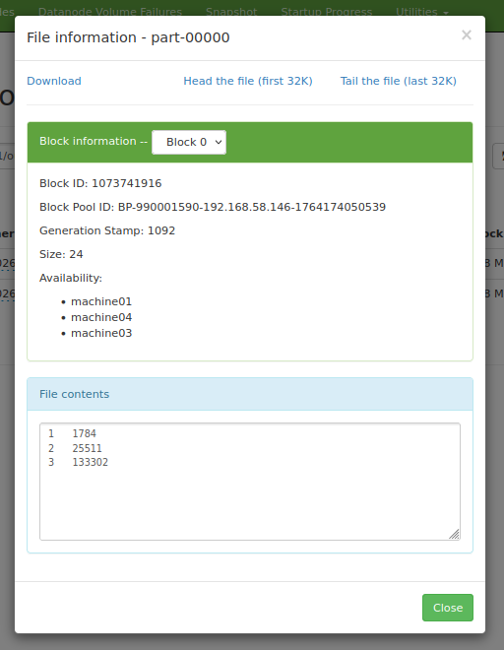
Fig. 2. HDFS block metadata illustrating file replication across multiple nodes.
This image shows detailed block metadata for an output file, including block ID, storage nodes, and replication locations. It demonstrates how HDFS stores multiple replicas of data blocks across different machines for resilience.
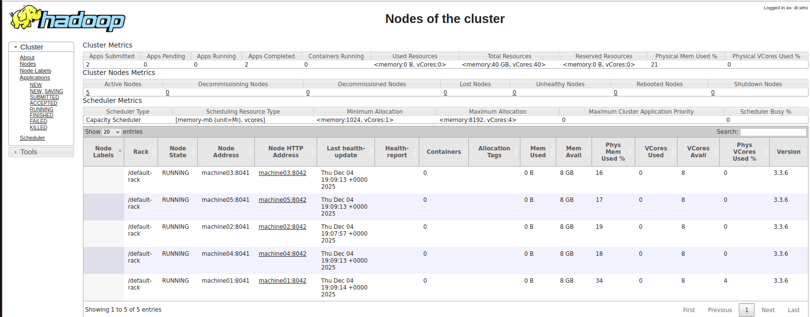
Fig. 3. YARN ResourceManager scheduler interface displaying cluster resource allocation and task scheduling.
This screenshot presents the ResourceManager scheduler dashboard, highlighting cluster resource usage, container allocation, and scheduling statistics. It illustrates how tasks are dynamically distributed across nodes to optimise performance.
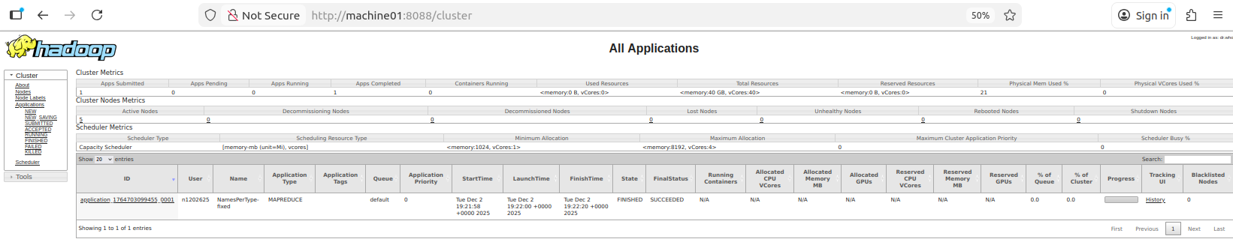
Fig. 4. Cluster node status panel showing active worker nodes, resource availability, and health monitoring.
This figure shows the cluster node monitoring panel with running node states, memory usage, CPU allocation, and health reports. It confirms that all worker nodes were active and communicating correctly during execution.

References
Armbrust, M., Fox, A., Griffith, R., Joseph, A.D., Katz, R., Konwinski, A., Lee, G., Patterson, D., Rabkin, A., Stoica, I. and Zaharia, M. (2010) A view of cloud computing. Communications of the ACM, 53(4), pp. 50–58.
Apache Software Foundation (2024) Apache HBase Reference Guide. Available at: https://hbase.apache.org
Banker, K. (2011) MongoDB in Action. Manning Publications.
Chang, F., Dean, J., Ghemawat, S., Hsieh, W., Wallach, D., Burrows, M., Chandra, T., Fikes, A. and Gruber, R. (2008) Bigtable: A distributed storage system for structured data. ACM Transactions on Computer Systems, 26(2), pp. 1–26.
Chodorow, K. (2013) MongoDB: The Definitive Guide. O’Reilly Media.
Dean, J. and Ghemawat, S. (2008) MapReduce: Simplified data processing on large clusters. Communications of the ACM, 51(1), pp. 107–113.
George, L. (2011) HBase: The Definitive Guide. O’Reilly Media.
Gray, J. and Reuter, A. (1992) Transaction Processing: Concepts and Techniques. San Francisco: Morgan Kaufmann.
Lakshman, A. and Malik, P. (2010) Cassandra: A decentralized structured storage system. ACM SIGOPS Operating Systems Review, 44(2), pp. 35–40.
Shvachko, K., Kuang, H., Radia, S. and Chansler, R. (2010) The Hadoop Distributed File System. Proceedings of the IEEE 26th Symposium on Mass Storage Systems and Technologies (MSST), pp. 1–10.
Stonebraker, M. and Çetintemel, U. (2005) “One size fits all”: An idea whose time has come and gone. Proceedings of the IEEE International Conference on Data Engineering (ICDE), pp. 2–11.
Stonebraker, M. and Hellerstein, J.M. (2005) What goes around comes around. Proceedings of CIDR Conference.

